Meal & Calorie Tracker

This document provides a technical overview of the Meal & Calorie Tracker n8n workflow. This automation allows users to log meals via Telegram using text or photos and receive instant calorie estimations and nutritional daily and weekly summaries powered by AI.

Workflow
The primary goal of this workflow is to simplify calorie tracking by eliminating manual database searches.

Key Scenarios:
- Meal Logging (Text): User describes a meal ->AI estimates calories -> Data is saved to Google Sheets ->User receives confirmation with remaining daily calories.
- Meal Logging (Photo): User sends a photo -> Vision AI analyzes the image ->Items and calories are extracted -> Data is saved to Google Sheets -> User receives confirmation with remaining daily calories.
- Daily Summary: User sends /summary -> AI analyzes the entire daily log -> User receives a macronutrient breakdown and nutritional advice.
- Weekly Summary: User sends /weekly -> AI analyzes the last 7 days of logs -> User receives long-term nutritional trends and professional suggestions.

Key Nodes and Logic
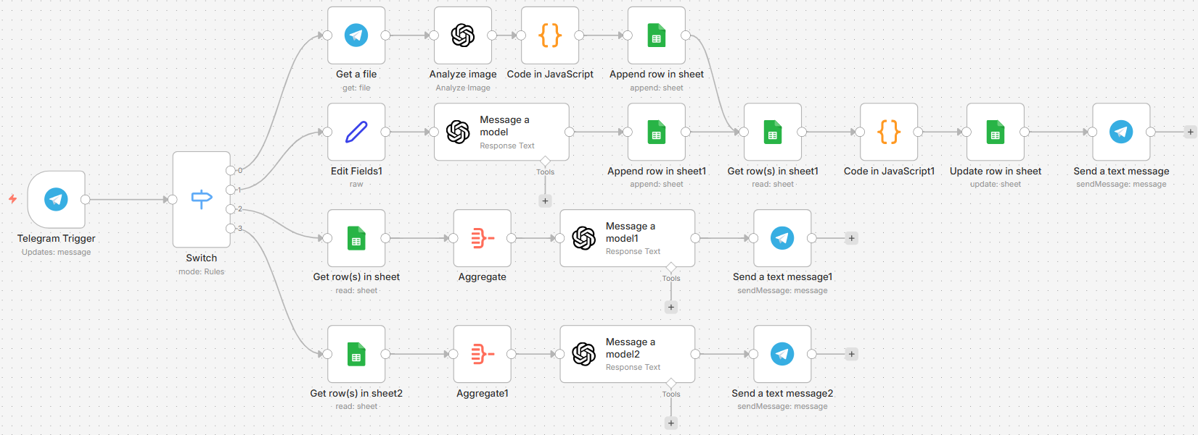

The workflow utilizes a Switch Node to route data through four distinct logical paths.

Trigger & Routing
- Telegram Trigger: Captures messages or photos.
- Switch (Router): Directs traffic based on content:
  - Path 1 (Photo): Routes to Vision Analysis if a photo is detected.
  - Path 2 (Text): Routes to Text Processing if natural language is used.
  - Path 3 (Summary): Routes to Daily Analysis if the message is /summary.
  - Path 4 (Weekly): Routes to Weekly Analysis if the message is /weekly.

- Path 1: Photo Analysis (New Feature)
- Get a file: Downloads the image binary from Telegram servers.
- Analyze image (OpenAI): Uses GPT-4o-mini to identify food items and estimate portion sizes and calories directly from the image.
- Code (JS): Cleans the AI output by stripping Markdown formatting to ensure the data is a valid JSON object.
- Append row in sheet: Logs the meal, timestamp, and metadata into a Google Spreadsheet.

- Path 2: Meal Logging (Text)
- Edit Fields1: Extracts username and text from the Telegram payload.
- Message a model (OpenAI): Uses GPT-4.1-mini with a JSON Schema to force consistent output of calories and items.
- Append row in sheet: Logs the meal, timestamp, and metadata into a Google Spreadsheet.

- Path 1 and Path2 (continue):
  - Get row(s) in sheet: Retrieves today's entries.
  - Code in JavaScript1: Performs the math:
remaining_calories = previous_remaining - new_meal_calories
if it is the first entry of the day:
remaining_calories = daily_calorie_goal (1800) - new_meal_calorie
  - Update row & Send text: Updates the sheet with the new balance and notifies the user.

- Path 3 & 4: Analysis (Top Branches)
- Get row(s) (Daily/Weekly): Fetches relevant meals for the selected timeframe.
- Aggregate: Combines individual meal items and calories into a single array for AI analysis.
- Message a model: Estimates Proteins, Fats, and Carbs, and generates 3 professional suggestions.

3. Example Data
Input (User message): “120 g salmon and 200 g fried potatoes”
Output (Telegram):
🍽 Meal logged successfully!
📝 Items: salmon, fried potatoes
🔥 Calories: 650 kcal
✅ Remaining calories today: 1150 kcal. Keep going! 💪
Input (Photo):
Output (Telegram):
🍽 Meal logged successfully!
📝 Items: "rice","vegetable patties"
🔥 Calories: 500 kcal
✅ Remaining calories today: 650 kcal. Keep going! 💪
Input: /summary
Output (Telegram):
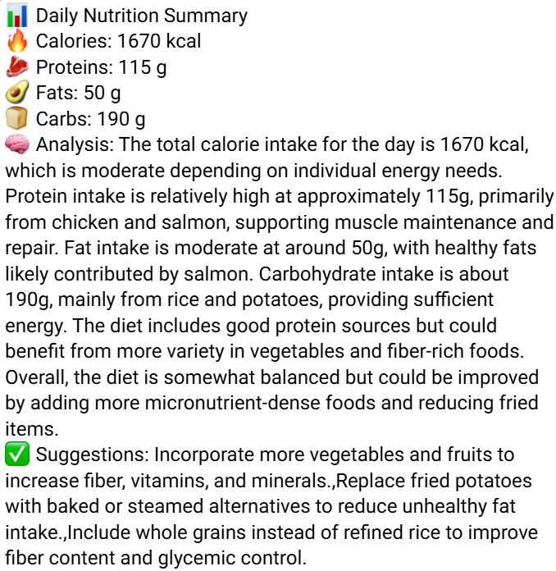

- Challenges
Challenge | AI-Assisted Solution
Markdown "Clutter" | AI often returns JSON inside code blocks (```). A JS Code Node was implemented to strip these characters using Regex before parsing.
Tracking "remaining calories" across multiple messages. | Implemented a JavaScript Code Node to handle the math by fetching the last known state from Google Sheets and subtracting the new AI-generated value.
Image Extraction | Telegram provides file paths, not files. The Get a file node was used to download the binary so the Vision AI could "see" it.

- AI Improvement Impact

  - Zero-Database Maintenance: No manual food database is needed; AI provides internal knowledge.
  - Visual Portion Estimation: Integration of Vision AI solved the problem of users not knowing exact weights, allowing the workflow to estimate calories directly from visual plate volume.
  - Structured Data Enforcement: Using JSON Schemas ensures the automation never breaks due to unexpected AI text formatting.
  - Actionable Advice: Summaries provide professional coaching tips beyond simple counting.

Video demonstration link: https://youtu.be/WgjVmV2PhWE

